**Name**: MAHORO Raphaela

**ID**: 24073

**ASSIGNMENT 2**

1. Created Docker file and converted project to war file

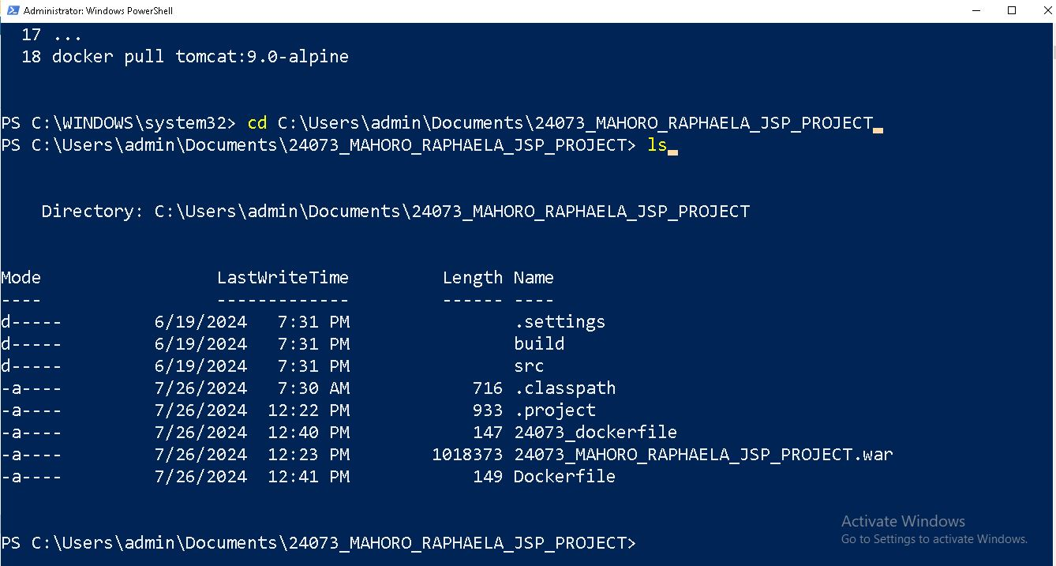

2. in the docker file edit

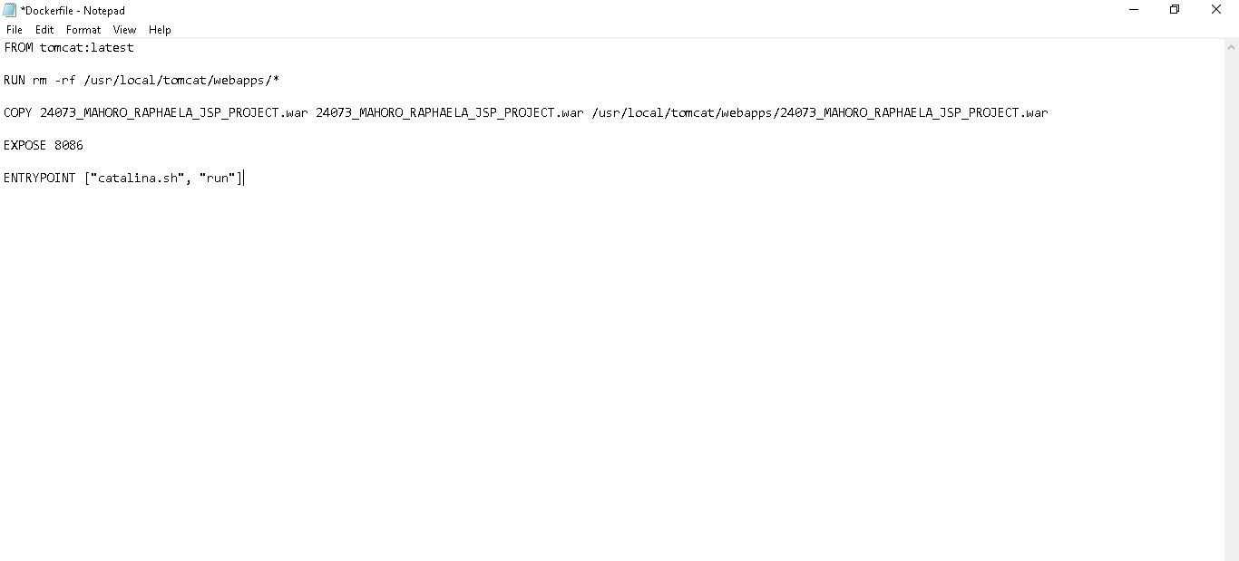

3. after editing build image called 24073_mahoro_raphaela_image

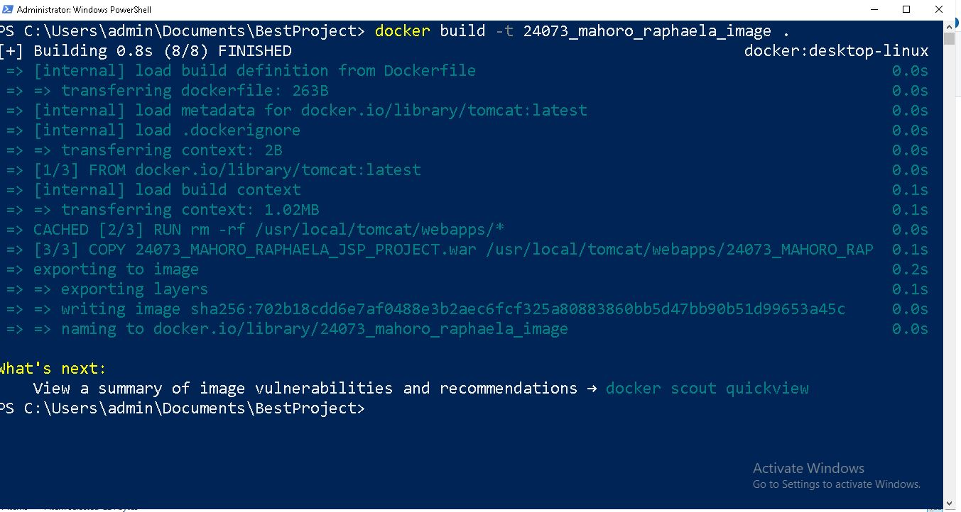

check to see if the image was created

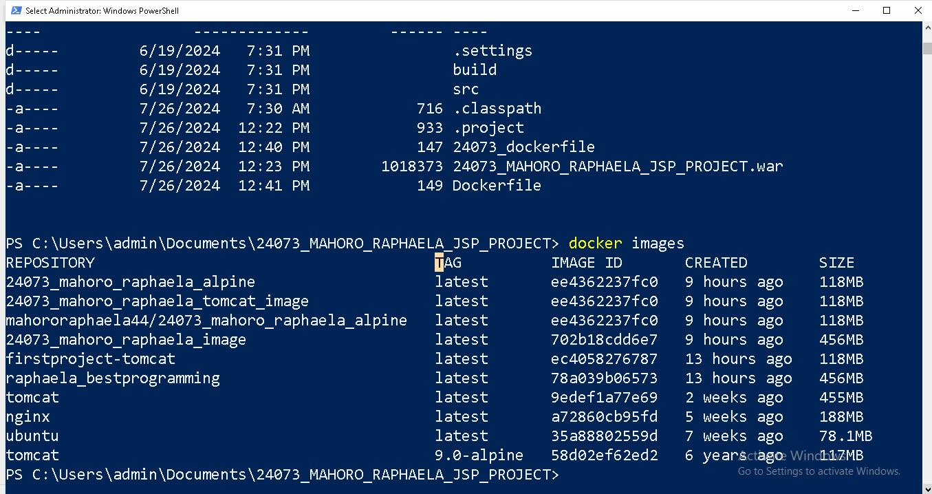

4. edit the Dockerfile to reduce size

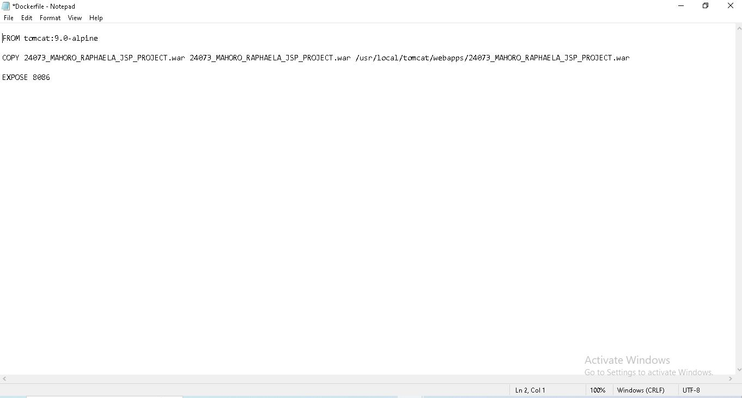

Build image for alpine



Start a container from the new image

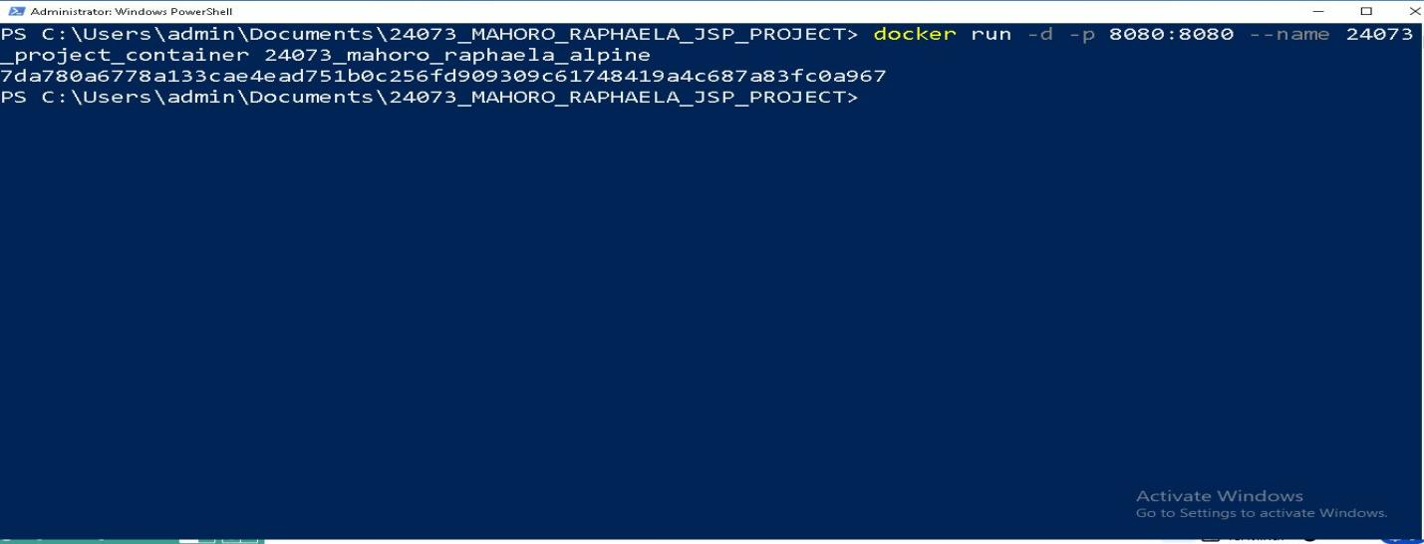

Check if your container is running and if your application is accessible:

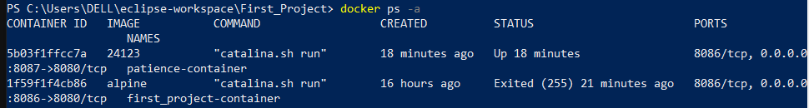

5. Push the image 24073_mahoro_raphaela_alpine

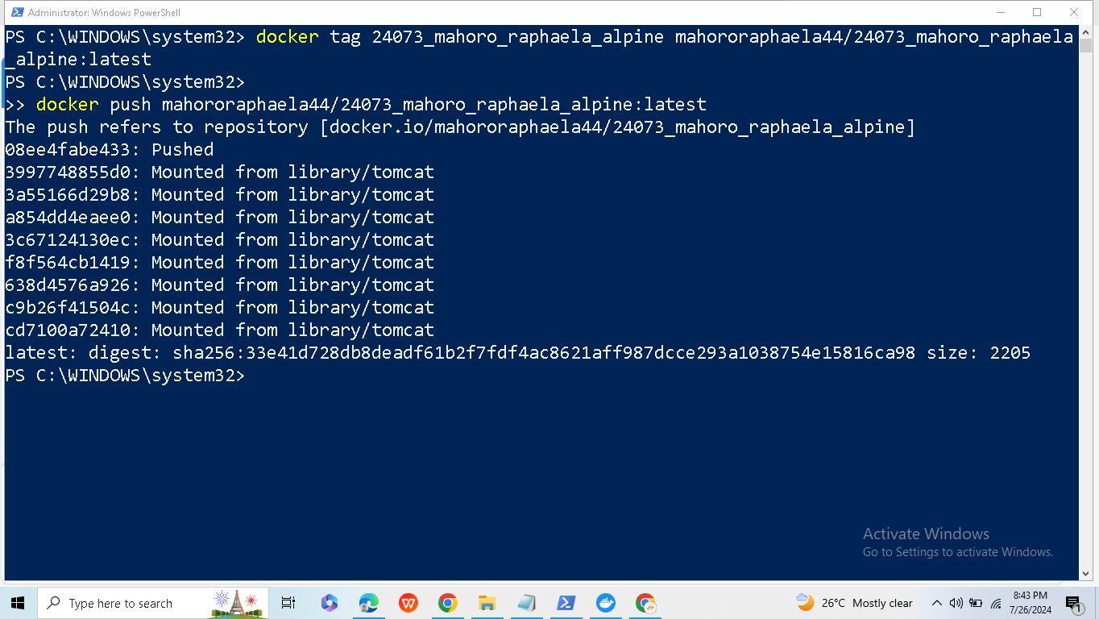

6. Pull the Image

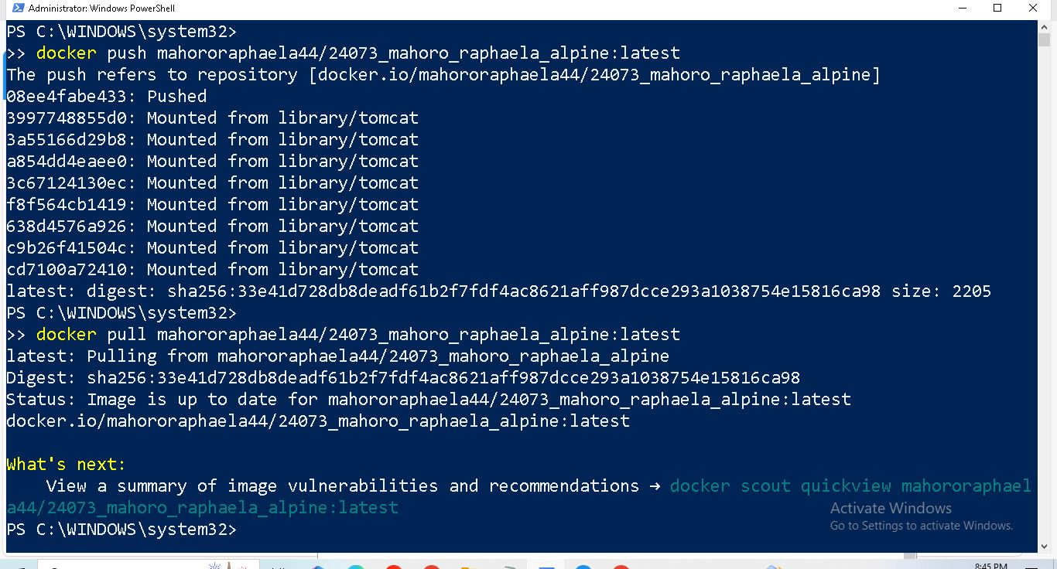

Check

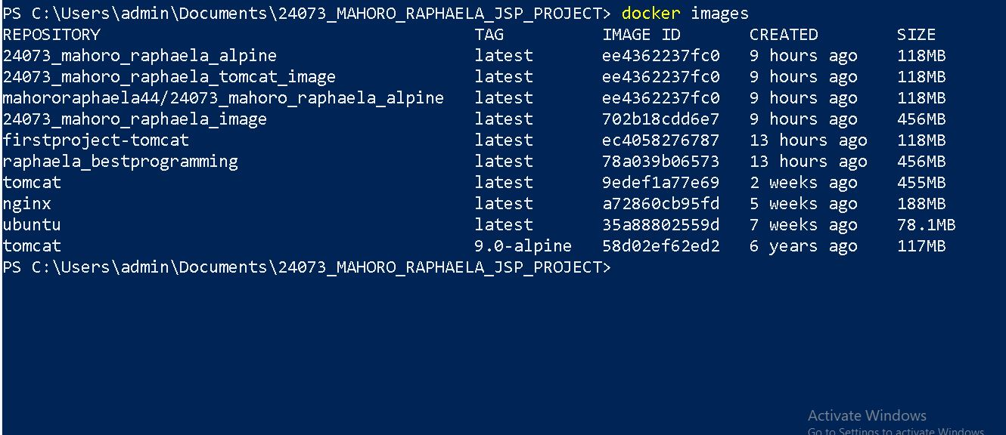

We can see that the image 24073_mahoro_raphaela_alpine was pulled

Check if it runs as an image

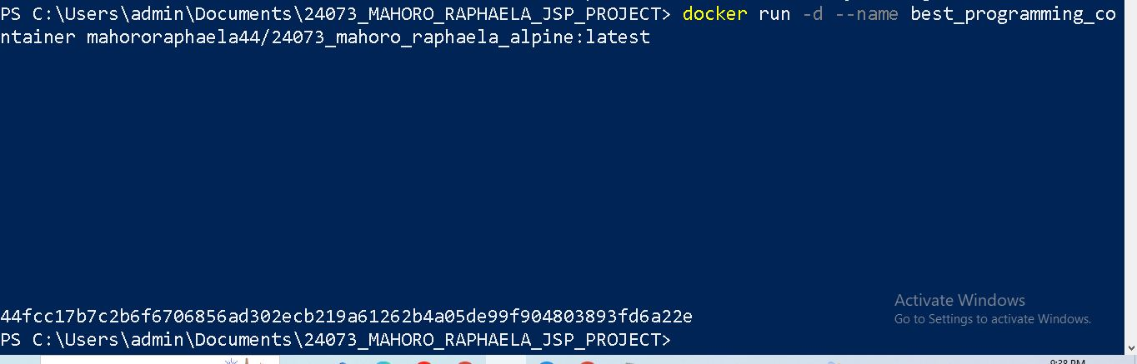

Then run docker ps

